**Master’s Thesis Proposal**

**Real-time Global Illumination using Voxel-based Ray-bundles**

**Che Sun**

**Advisor: Emmanuel Agu**

**Department of Computer Science**

**Worcester Polytechnic Institute**

**Abstract**

Real-time global illumination has gained more and more interests in recent years due to the rapid evolvement of GPU computing power. Some approaches have been developed to try to simulate global illumination as accurate as possible by implementing robust ray-tracing algorithms using Shader Model 5 features of current GPUs. For example, bidirectional path tracing is employed to resolve the classic singularity issue of instant radiosity. While the rendering speed is acceptable for a certain level of scene complexity, maintaining high frame rates for arbitrary scenes is still a challenging work. In this thesis, we propose a novel hybrid rendering system that combines bidirectional path tracing and scene voxelization to accelerate virtual point light (VPL) visibility tests and global ray-bundles generation. Meanwhile, we show that caustics maps can be integrated into the system easily as well.

Keywords: real-time global illumination, instant radiosity, global ray-bundles, scene voxelization, caustics maps

**1 Introduction**

Global illumination is an important lighting effect that simulates light propagation behavior in 3D space. It increases fidelity of computer generated images dramatically and thus has been an active research area in the field of image synthesis. Since the formal introduction of light transport equation [Kajiya 1986], many CPU-based off-line algorithms have been invented to solve it. While these techniques generate physically correct images, the speed of creating them are usually slow. Figure 1 shows images generated by PBRT, which is a CPU-based global illumination rendering system.

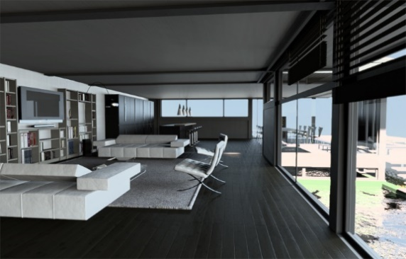 

Figure 1. Image courtesy of PBRT. Left: Modern villa scene by Florent Boyer. Right: Jade Dragon by Rui Wang.

In order to implement global illumination for real-time applications such as video games, several approaches have been introduced. One class of these approaches is called many-light based method, derived from [Keller 1997]. It provides a simple lighting computation framework that transforms the problem of solving lighting transport equation to the calculation of the direct illumination from many virtual light sources. The key observation is that general light transport problem can be approximated by generating a set of virtual light sources and doing direct illumination from them. This makes it a hardware-friendly algorithm which could be implemented on modern GPUs easily.

While bias could be reduced by increasing the number of virtual light sources, frame rates will suffer if too many virtual light sources are generated and used for rendering. Most existing many-light based real-time approaches use shadow maps to do the visibility tests for indirect illumination calculation, which is currently the main bottle neck of them.

General real-time many-light methods also suffer from a singularity issue caused by failure of the sampling strategy at corners of scene geometry, where the distance between shading point and virtual light source is too close. One way of resolving this problem is clamping, which leads to incorrect rendering result. [Tokuyoshi 2012] introduces a better solution using bidirectional path tracing on GPU. They combine the many-light method with global ray-bundles method to construct a lighting path from both the virtual light source and the camera. Thus the overall rendering quality is improved. However, using global ray-bundles further increases the burden, since additional scene rendering task must be issued to create a ray-bundles for each virtual light source.

Another class of real-time global illumination methods make use of so called “voxels” to discretize to original scene representation. There are several advantages using scene voxelization: First, it is a geometry-independent scene description and some fast scene voxelization methods have been developed. Second, ray-geometry intersection and visibility tests can be performed very fast on such data structure. Third, high quality anti-aliasing techniques can be implemented using voxelization as well [Crassin 2011].

In this thesis, we introduce a hybrid real-time global illumination system which combine the many-light method, global ray-bundles and scene voxelization together. By doing so, good rendering quality and speed could be achieved at the same time. We will replace the expensive VPL shadow maps generation task with a fast scene voxelization technique. Furthermore, we will use this voxelized scene description to generate imperfect global ray-bundles. Here, we call them voxel-based ray-bundles. This task should be much faster than the original method in [Tokuyoshi 2012]. Afterwards, we will implement an improved version of caustics maps using GPU concurrent link list [Yang 2010]. Integration of this technique into our system shall be simple since the system will be designed and implemented fully base on Shader Model 5 features.

2 Related Work

Instant Radiosity [Keller 1997] is a theoretical correct and hardware-friendly algorithm that solves the light transport equation [Kajiya 1986] efficiently. It allows fully dynamic scenes, which is suitable for interactive applications such as video games. General naive method creates many virtual point lights (VPL) in each rendering frame by sampling the scene description and then uses shadow maps to do the visibility tests when shading a fragment. Although intuitive and simple to implement, this method will hurt the frame rates a lot since VPL shadow maps creation requires sampling the scene description many times (usually 100 -1000). Many methods are developed to address this problem. Reflective shadow maps [Dachsbacher and Stamminger 2005] captures scene surface points visible to light sources efficiently but ignores visibility test for VPLs. [Segovia 2006] uses interleaved sampling [Keller and Heidrich 2001] to reduce the number of VPLs needed for each pixel being shaded. [Lane et al 2007] maintains a set of VPLs and regenerate a subset of them incrementally to reduce the overhead of VPL shadow map regeneration. [Ritschel et al. 2008] employs point-based rendering for the VPL shadow maps. The key idea is that instead of using original scene polygon, they use a set of point samples for the primitive rasterization process, which is much faster than the original polygon primitive rasterization. While using few VPLs is desirable, it leads to downsampling issues such as flickering especially when part of the scene is animated. To address this issue, [Knecht 2009] exploits temporal coherence [Nehab et al. 2006] to filter out high frequency signals between consecutive rendering frames.

To improve the rendering quality, [Tokuyoshi 2012] changes the sampling strategy of VPL to bidirectional path tracing [Lafortune and Willems 1993; Veach and Guibas 1994]. This algorithm is known to be robust and resolves the failure of VPL sampling strategy successfully. They implement the algorithm efficiently on Shader Model 5 featured GPU by using global ray-bundles [Sbert 1996] and GPU concurrent link list [Yang 2010] to construct a shading path from both a VPL and the viewing camera. Figure 2 shows their result.



Figure 2. Image courtesy of [Tokuyoshi 2012]. Real-time Bidirectional Path Tracing using VPLs and global ray-bundles.